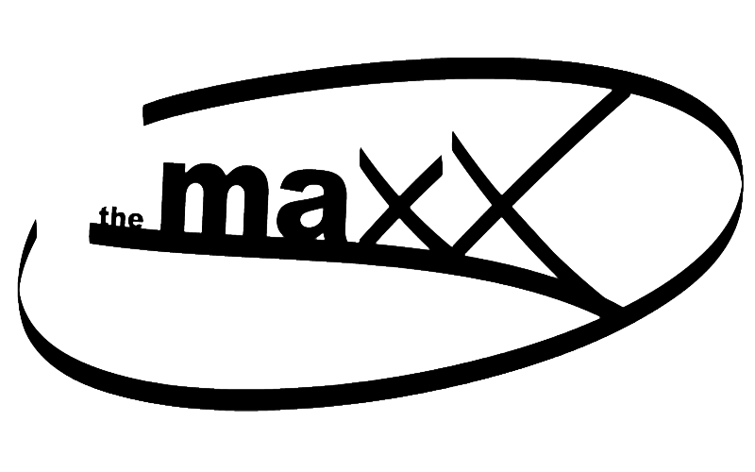

94 Railroad Street, New Milford, CT 06776
860.210.2030 fax 860.210.2016
RENTAL AGREEMENT

Name of Applicant and / or Organization: ____________________________________________

Address: ______________________________________________________________________

Represented by: _________________________________________________________________

Date(s) Requested: ____________________________ Time From: _______ To: _____________

*The introduction of decorations is permitted with prior permission only.

Space Requested: _______________________________________________________________

Person in charge and responsible for event:

Name: _____________________________Home#: ______________ Work#: _______________

Address: ______________________________________________________________________

The space will be used for the following purpose(s): ____________________________________

- Due to an unforeseen Act of God (weather) where the Maxx is unable to provide services, liabilities will be limited to the return of deposit within 14 days.
- The presence of drugs is expressly forbidden to occur on the property.
- No smoking is allowed on property.
- Users are responsible for all attendees of the event. Users are expected to control and limit entrance to the event and to supervise the activities of participants, invited guests and observers. The Maxx will provide one supervisor whose duties will include monitoring the event only.
- Users are financially responsible for and damages caused by attendees.
- DJ and catering services are available with prior arrangements.
- The Maxx allows the use of its tables and chairs with prior consent. Any additional tables and chairs needed may be rented through an outside agency and brought in and removed by the user.
- Use of the facility’s electrical, plumbing, lighting and mechanical systems is limited to existing capacities. No provisions for additional electrical power shall be provided without prior arrangement.
- Space is reserved in as-is condition. There is no warranty, expressed or implied, that the space can accommodate the intended use of the event sponsor.
- Combustion of any kind is expressly forbidden in any space, in any portion of the facility and on all grounds surrounding the facility.
- Cable television systems and other AV equipment are available with prior consent only.

- Users are responsible for cleaning facility upon completion of event including removal of trash and all decorations. Failure to return the space, and any portion of the facility used during the event, to the condition offered prior to the event constitutes a misuse of the space. Event sponsors shall be held financially responsible for any costs incurred by the MAXX for cleaning.
- The introduction of decorations, partitions, illuminated and non-illuminated signage, displays and similar construction is prohibited. The introduction of any such materials into the facility requires approval by The MAXX in advance of the event and may also require approval of the Town of New Milford Fire Marshall and the Town of New Milford building Department.
- Property of the MAXX which may be present in rooms at the time of an event is not to be disturbed in any way.
______________________________________________________________________________

Complete, sign and return with a deposit of $ 50.00.

The day of the event, I agree to pay the remaining balance due of $ _________________.

In consideration of the grant of permission to use The Maxx facilities, _______________
hereby agrees to indemnify and save The Town of New Milford harmless against all claims, demands, suits, judgments or other forms of liability, including legal fees and costs, if any which may arise out of the use of the facilities.

If alcohol will be present, a town permit and a current, valid Certificate of Insurance in an amount not less than $2,000,000 naming the Town of New Milford as additional insured, must accompany your signed Agreement / Contract.

Business or organizations must have a valid Certificate of Insurance in an amount not less than $1,000,000 naming the Town of New Milford as additional insured, must accompany your signed Agreement / Contract.

Private parties over 100 people must have a valid Certificate of Insurance in an amount not less than $1,000,000 naming the Town of New Milford as additional insured, must accompany your signed Agreement / Contract.

I hereby certify that the use for which this space is requested conforms to the permitted use of The Maxx and agree to pay balance due for the date(s) and services requested.

Date: _________________________________

Signature: _____________________________

DJ: _______________ DRINKS: ____________ CATERED FOOD: _______________

SPECIAL INSTRUCTIONS: ______________________________________________

